Ideation Phase Empathizes Discover

Date | 20 February 2026
Team ID | LTVIP2026TMIDS82725
Project Name | Plugging into the future:  An exploration of electricity consumption patterns using tableau
Maximum Marks | 4 Marks
Empathy Map Canvas:
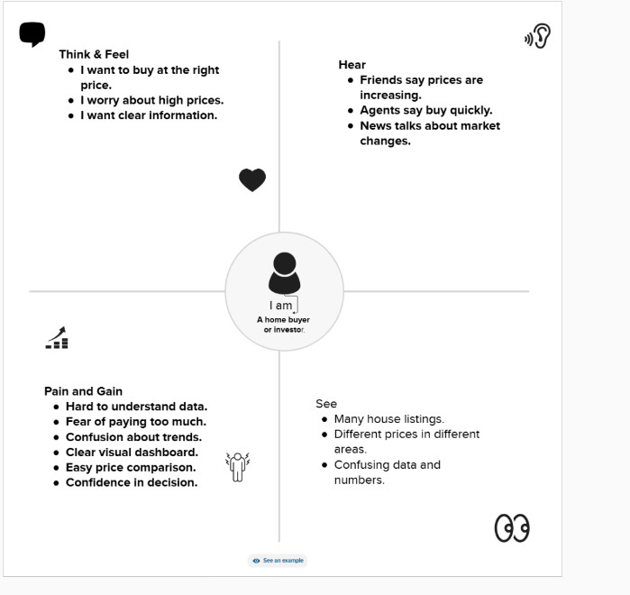
Reference: https://www.mural.co/templates/empathy-map-canvas

